**Code Report for COMP3053Checker and COMP3053CheckerTest**

**COMP3053Checker**

**Base Information**

1. The class of the program has two constructors: 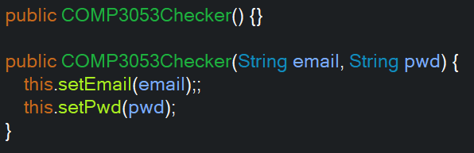

You can add other suitable constructors according to other requirements.

1. There are five methods for both email and password parts.

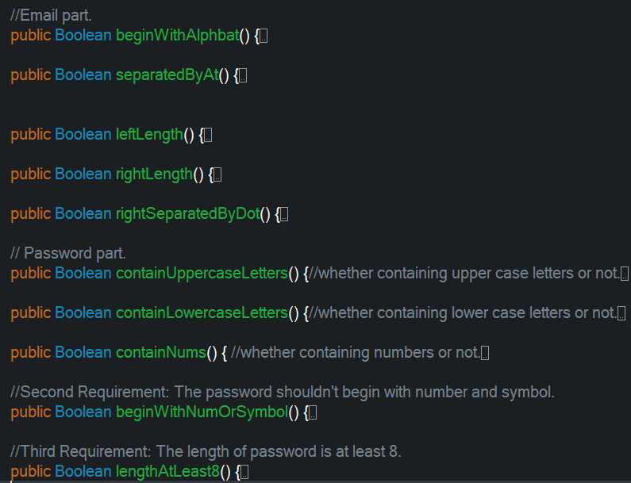

1. The workflow of main() function is in User Manuals

**Main Algorithms Used in Methods**

**Email**

In “beginWithAlphabet()”:

* Get the first char using substring(0,1) in String type, which is easy to match the pattern created using the regular expression “[A-Za-z]+”.

In “separatedByAt()”:

* Judge “email.split("@").length == 2” directly. Because the method split() will return an array of contents from the email, if there’s no “@” in email or “@” is on the edge of email, split() method will return an array whose length is 1. Thus, we can know if the email meets the requirement.

And the same way used in “rightSeparatedByDot()”.

**Password**

The first three method is transfering each character in the password to judge if meet the requirement or not. And “beginWithNumOrSymbol()” method has the same way as “beginWithAlphabet()”.

**COMP3053CheckerTest**

There’s no complex algorithms in this test program, each test method uses “assertEquals()” to monitor corresponding method in main program. You can add test methods according to other requirements.